Assignment1
Project: - AI-Based Language Tutor
Course Number- ACS-2913-001
Course Name- Software Requirements Analysis And Design
Students Name - Manmeet Singh[ St id- 3177236]
Daljeet Singh[ St id- 3169763]
Instructor – Victor Balogun

AI-BASED LANGUAGE TUTOR

Problem Description
Language learning platforms have become an important aspect and convenient way for today’s era for language learners by providing language learning tools and programs in form of lessons, activities and so on. However, these platforms utilize a one-size-fits-all approach for every learner. It is important for tutor to have wide variety of learning styles and proficiency levels and able to gather information about the user as well as to adapt according to learner’s(user) requirement in their learning process. It should play a vital role in maintaining consistent progress, timely feedback, non-repetitive resources as per learners needs. Additionally, it is important to also focus on less commonly languages along with in-demand languages.
So, it is suggested that a new language tutoring system based on AI be developed(app name:-bilingue), which addresses all the problems and provides a flexible, personalized, adaptive, as well as interactive learning environment to their users.

System Capabilities
The new system should be capable of:
- Collecting information regarding the users’ strengths and weaknesses based on activities they did on the system, which also help to adjust learning materials of learners as per their level.
- Providing regular feedback (with help of AI-Based interface), such as mentioning the sights need improvement and the ones which are improved, based on their performances in practice sheets, modules, tests etc.
- Engaging with learners by having interactive conversation on random topics related to real life situation, political and many other, which results in the improvement of speaking skills.
- Focusing not only on the learning of popular languages but also on less common languages.
- Providing interactive practices in the form of games such as quizzes, words puzzle and making stories by analysing image so to have some enjoyment along with learning.
Benefits:
The new system of language tutoring on AI-Basis will provide the following benefits-
- User friendly as it provides learning styles as per the user’s need, results in easy and quickly learning of language, no matter of age.
- Become easy for the institutions and other tutoring organizations to deliver sessions to students.
- Increases user engagement by having interactive conversations sessions and practice in the form of games.
- Provides all historical information of modules, making easy tracking of improvements.
- Gives flexible, personalised, adaptive as well as interactive learning experience to users.

Stakeholder List
In the system, Stakeholders play a pivotal role in continuous feedback and collaboration. The major stakeholders engaged in the progress are as follows:
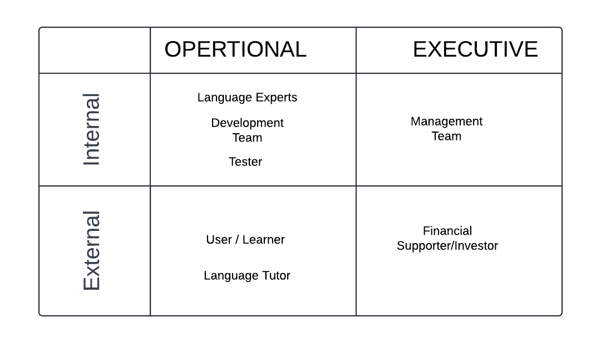

Internal Stakeholders-
- Language Experts (Operational Stakeholders)- They will validate and ensure the teaching methods, content, and exercises delivered to learners are perfectly fine or not.
- Development Team (Operational Stakeholders)- They are responsible for building and maintaining the software.
- Tester (Operational Stakeholders)- Ensure that the software application working properly, using machine learning models for conversation, feedback and providing adaptive learning.
- Management Team (Executive Stakeholders)- responsible for the software development’s requirements, following up project timelines, deliverables, and quality assurance.

External Stakeholders-
- Users/Learners (End Users)- They are primary users of the software for the language learning, who also give feedback or satisfaction (as a customer) on their utilization.
- Financial Supporters/Investors (Executive Stakeholders)- They are responsible for providing funds as per the budget or equity in return of shareholdings.
- Language Tutoring Schools or Institution (End Users)- These organisations use the software application as a supplemental tool for their learners.

Requirements Gathering Approach
This process is helpful on obtaining a clear understanding of needs and expectation from iterative interactions with stakeholders. Some commonly used approaches are:
- User Stories- gathering information from user’s perspective.
Example- “As a language learner, I want to get my daily, or weekly updates of the scores in modules, quizzes and conversation, so that I get to know about my improvement in language.”
- Collaborative Workshops- The approaches like brainstorming sessions and story mapping workshops with language experts, institutions, and other users help to get know about what other factors are required in software application.
- Daily Stand-Up Meetings- The technique like scrum is used for the interaction with all team members to discuss about progress, working on complex stuffs, and details are being changed or added.

Requirements Documentation
System requirements, which is categorised into functional and non- functional requirements, for AI-Based Language Tutor is classified using FURPS model (Functionality, Usability, Reliability, Performance, Security)-
Functionality Requirements
- The System must deliver language lessons based on the learner’s learning style and pace.
- It has to adjust the difficulty of learning materials as per user’s level.
- The Software Application should give regular feedbacks (with help of AI-Based interface) based on learner’s performance.
- It includes practices modules like quizzes, worksheets, puzzles and speaking session.
Non-Functional Requirements
- Usability-The system ought to have user friendly interface that is easy to navigate for learners of different age groups.
- Reliability- It should be capable of supporting offline learning, allowing users to download modules and access them without an internet connection.
- Performance- It should be capable of handling surplus of learners at the same time without having decline in performance.
- Security- It has the capability that all user’s information such as personal details, their scores must be encrypted and have limited access to authorised officials.

Activity Diagrams
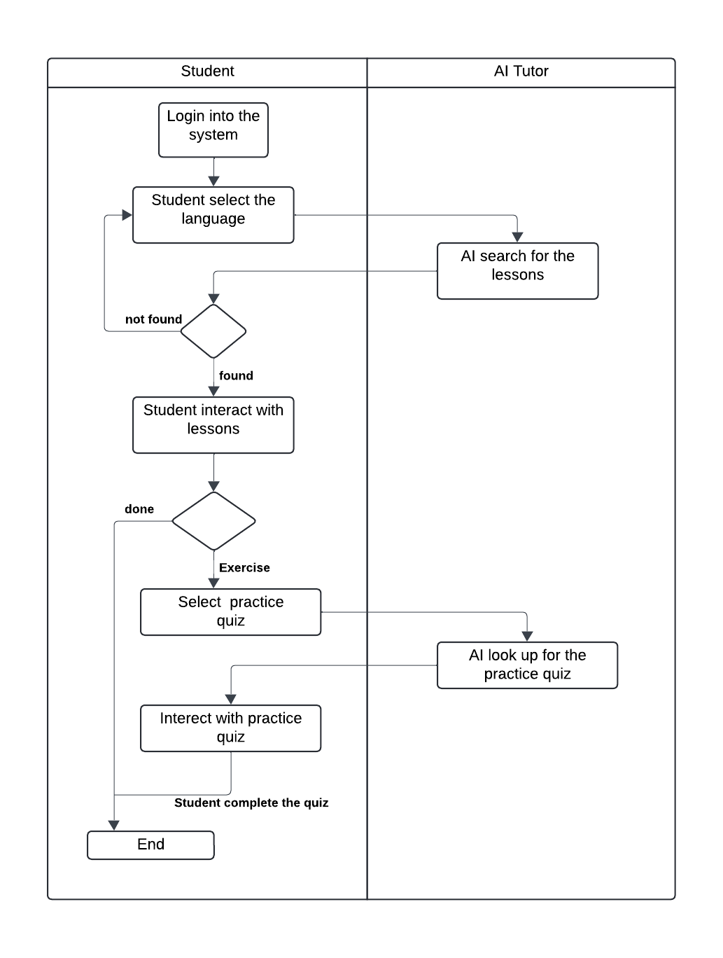

There are few Activities of AI-Based tutoring system-
- Language Learning Lessons
- Learner/User logs into the software application.
- He or she chooses the language want to learn.
- He or she selects the style and pace of learning.
- The software starts the language session.
- After it’s completed, user gives the feedback about the experience on lesson.
- The application keeps the record of feedback for future so as to adjust the way of tutoring as per the user’s feedback.
- Modules or Exercises
1. User logs into the system.
2. User goes to exercises area and select which type of module he or she wants to perform.
3. The system starts the exercise and even guides the user through the module.
4. After the completion, the system gives the feedback or score based on performance.
5. The software keeps the record performance so as to adjust the difficulty level of exercise in future.

Work Breakdown Structure (WBS)
- Sprint1: Language Learning Session
- User Story: “As a user, I want to select the style and pace of learning, so to have easy learning of language.”
- Tasks:
- Develop a user interface to select the language, style and pace of learning.
- Starts the language session as per the requirements.
- Build a system to get the feedback from users as per their experience.
- Develop the coding to keep record of feedbacks and use AI-System to make adjustment in learning sessions as per their needs.
- Acceptance Criteria: User can choose language as well as learning method, then complete session and provide feedback on the basis of experience.
- Sprint2: Modules or Exercises
- User Story: “As a user, I want some exercises or modules to do practice for the language.”
- Tasks:
- Make modules, or exercises and even the system for them.
- Conduct practice sheets, quizzes, conversation sessions.
- Develop Software with AI-System to keep record (for future’s perspective) as well as to deliver feedback or score on basis of the user’s performance.
- Build system to get the feedback from user about difficulty, experience so as to make adjustments in the difficulty level for future.
- Test the system as a user.
- Acceptance Criteria: User can complete modules, get feedback for performance and give feedback or difficulty and experience.
- Sprint3: Tracking Language Improvement
- User Story: “As a user, I want to know the performance in
language so that I can track my improvement in
the language.”
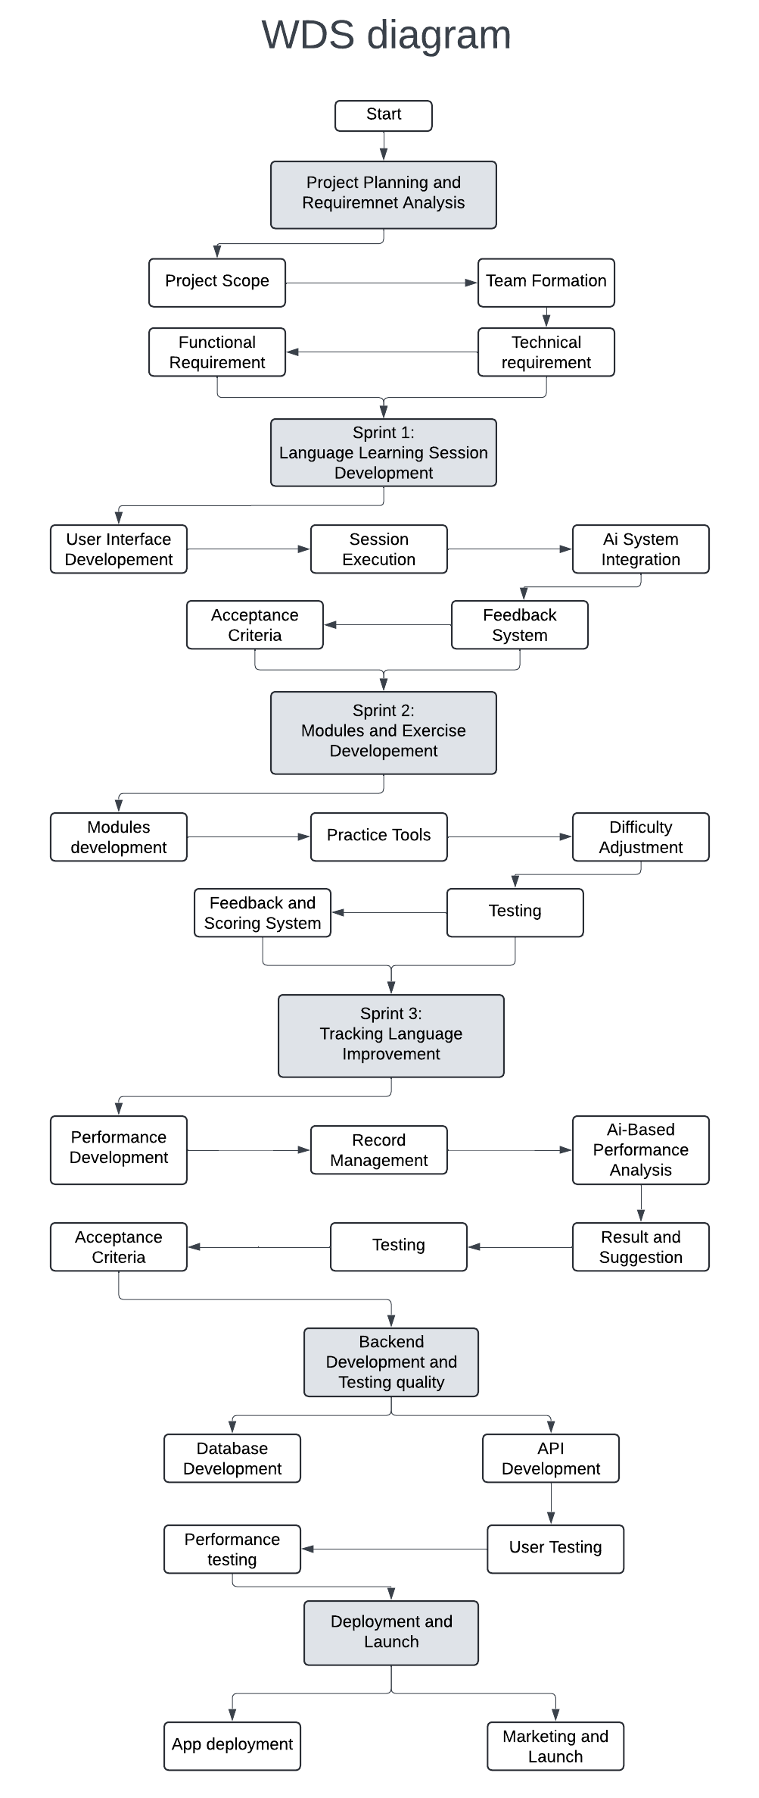
- Tasks:
- Build a performance section in the system.
- Develop a system to keep records of the scores and feedback in practice session.
- Use AI-Based interface, coding for performance analysis.
- Delivers the results in the form of graph and numbers, as well as give suggestion on its basis.
- Test the software as a user.
- Acceptance Criteria: User or learner can go to performance section in software, view past scores, feedback, and even see overall performance as well as the guidance on its basis.

WORKFLOW DIAGRAM:
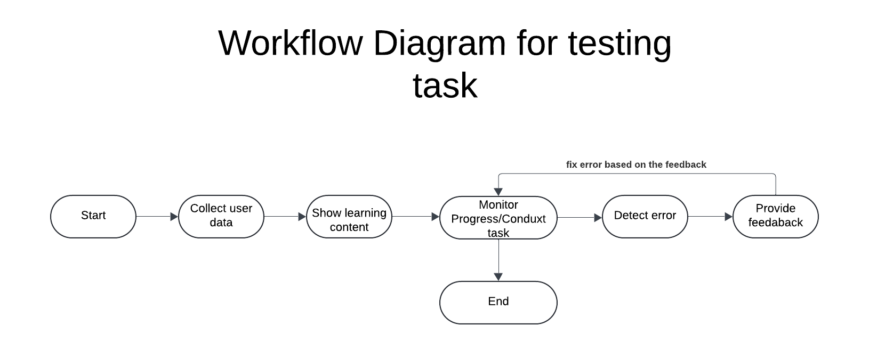

USE CASE DIAGRAM:
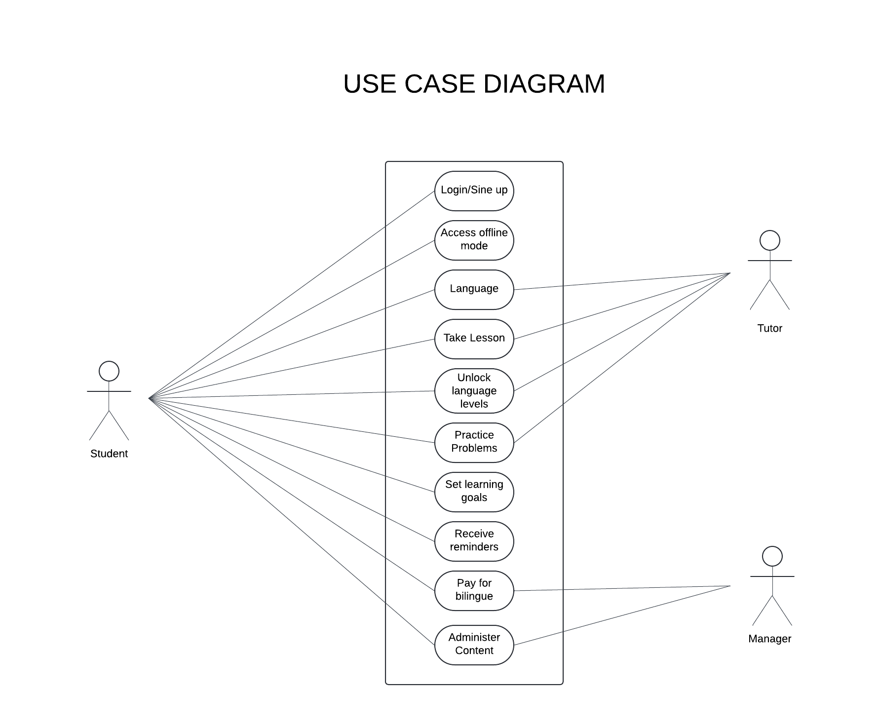

The use cases are list below:
- Student can create a new account.
- Student/user can access features and can choose the language.
- Student can attend the lessons.
- The tutor can manage all the lectures, content, see the platform usages through the users.
- Tutor can look up lessons for the user.
- Student can pay for the subscription so that user can use the advanced features.
- User can also modify the setting so that users can get the daily notice of their lessons and track the progress.

PRODUCT BACKLOG:
ID | As a | I want to able to | So that | Priority | Sprint | Status
1 | User | Take personalised lessons | I can improve my language skills | Must | 1 | Done
2 | Admin | See all the user | I can summarize the app visits | Must | 1 | Done
3 | Admin | Modify the outdated content or substitute | The content remain up to date | Must | 1 | Done
4 | User | Get real time feedback | I can see my mistakes | Must | 1 | Done
5 | User | Track the progress | I can see my progress | Must | 1 | Done
6 | Admin | Get security-based groups | I can protect the app from the bugs | Must | 2 | Done
7 | Visitor | Create an account | I can immediately start learning | Must | 1 | Done
8 | Visitor | Browse language courses | I can explore before paying for the subscription | Should | 2 | Work in progress
9 | Visitor | View the demo lecture | I can experience the platform environment | Could | 2 | Work in progress
10 | Admin | Can view the user progress | I can improve user experience | Could | 2 | To be started
11 | Admin | Generate the usage reports | I can see the success of the platform | Must | 1 | To be started

SUMMARY:
Bilingue, an AI-powered language tutor app, provides a customized and flexible learning experience. It collects user data, deliver individualized instruction, and modify course materials in response to student performance. To encourage participation and progress, the system uses interactive elements like tests, practice conversations, and real-time feedback. The initiative offers flexible, user-friendly language learning for both mainstream and less common languages, benefiting students of all ages and institutions. Language specialists, development teams, students, and investors are important stakeholders. The project uses agile development process that is structured and prioritizes sprint-based delivery, user input, and functional and non-functional requirements.

